**Day 1 Assignment 2: Draw your Home Network Topology and explain how you are accessing the RPS Lab environment.**

**Network Topology:**

Network topology refers to the structural arrangement of a network. The topological structure of a network may be depicted physically or logically. The network devices are depicted as nodes and the connections between the devices as lines to build a graphical model. In other words, a network topology means the manner in which a network is arranged, how the nodes are set up and connect to each other.

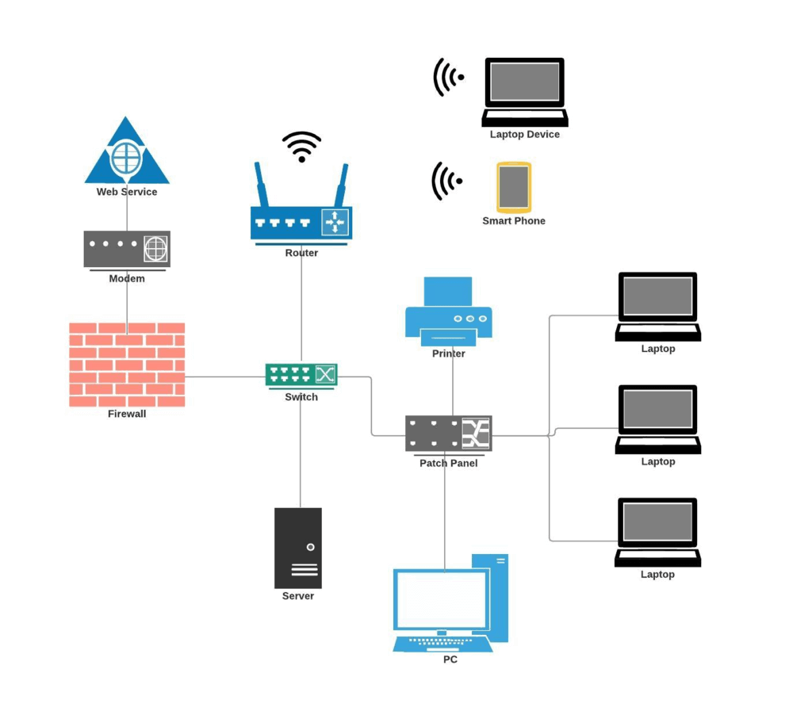

**PHYSICAL TOPOLOGY:**

The physical topology is the physical layout of your network. It refers to the placement of the various network devices such as the routers, switches,wireless access point, computers, etc. including the method employed to connect those devices, i.e. the network cables. Knowing the physical topology of your network is important because it helps you set up expansions, with maintenance, and for provisioning tasks.

**LOGICAL TOPOLOGY:**

Logical topology refers to the idea of how data flows within a network. It describes how the network is set up, how the nodes including virtual and cloud resources are connected to each other, and how data is transmitted through the network. Having a good grasp of the logical topology is essential for effective network management and monitoring, which ensures that your network is efficient and healthy.

**NETWORK INTERFACE CONTROLLERS (NICS)**

When you connect your computer to a network or depict a computer as a network node, it isn’t the computer that functions as a node. It’s only a piece of hardware inside your computer called the network interface controller (NIC) that performs this function. Along with the required circuitry, the NIC usually has a connector to receive the ethernet cable or an antenna for wireless communication. The NIC, thus, provides the computer with the capability to access the transmission media and to process the data flowing through the network.

**REPEATER & HUB:**

A repeater is a network device, which regenerates the Wi-Fi signal over the same network. It receives weak or corrupt Wi-Fi signals and regenerates it to the original strength. A Hub is just a repeater with multiple ports.

**ROUTER:**

Routers are the network devices that transfer packets of data between networks. It forwards the packets of data between networks by processing the routing information included in those packets.

**MODEM:**

A modem, short for modulator-demodulator, is a network device that helps your computer and other devices to connect with the internet.

**SWITCH:**

Aswitch is a network device that allows other devices on the network to communicate and share information. In other words, a switch ties the various devices such as PCs, printers, servers, etc. together into your network.

**FIREWALL:**

Afirewall is a network security system, which monitors and controls incoming and outgoing network traffic.

**BRIDGE:**

A bridge is a network device that connects and filters the traffic between two network segments.

**1. POINT-TO-POINT TOPOLOGY:**

As the name suggests, the point-to-point is a network topology with a dedicated link between two endpoints, hence it is the simplest topology. The advantage of such a network is that all the available networkbandwidth is dedicated to the two connected devices. You are not likely to use the point-to-point topology in your office network setup.

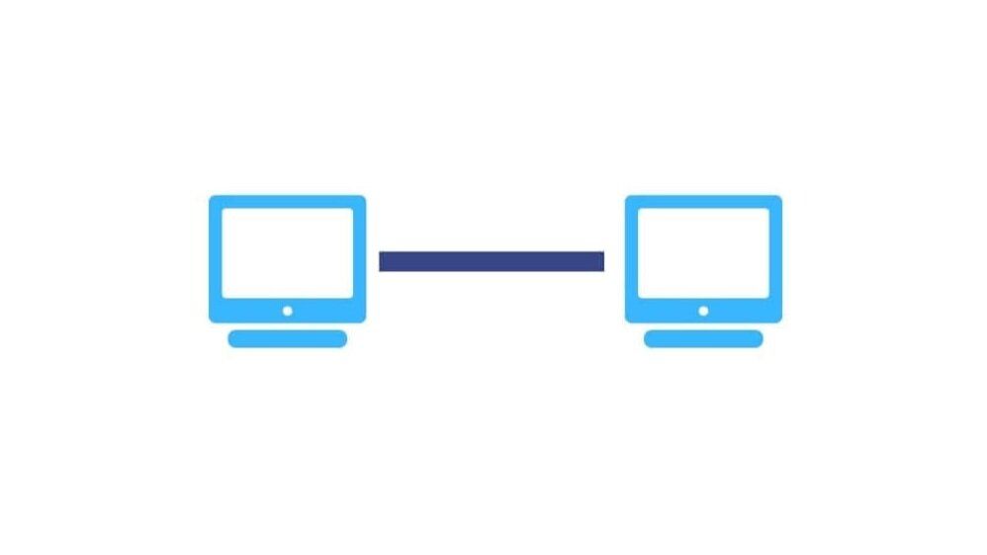

**2. DAISY CHAIN TOPOLOGY:**

A daisy chain is another simple network topology that is created by connecting each node end to end in series. When data is transmitted in a daisy-chained network, each node bounces it along in sequence until it reaches the destination. A daisy-chained network can be of two basic forms- linear (shown in the adjacent image) and ring, which we will talk about later on in this post.

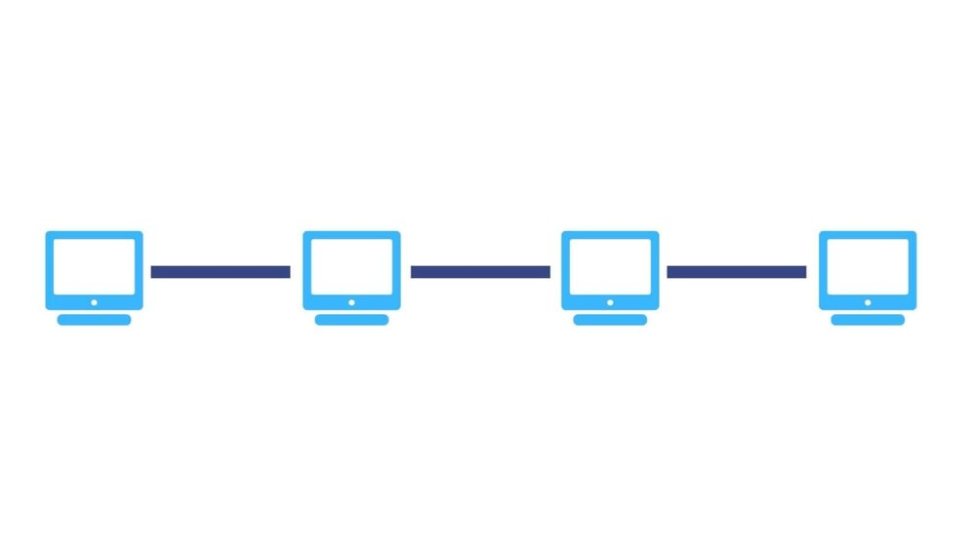

**3. BUS TOPOLOGY:**

A bus topology consists of a single cable, also called a bus, running from one end of the network to the other. In this network arrangement, each node is connected to the central cable or bus by interface connectors. A signal, containing the address and data, transmitted from the source node travels in both directions to all nodes until it reaches the destination node, which accepts the data. If the address of the delivered signal doesn’t match that of the receiving node, the data portion of the signal is ignored.

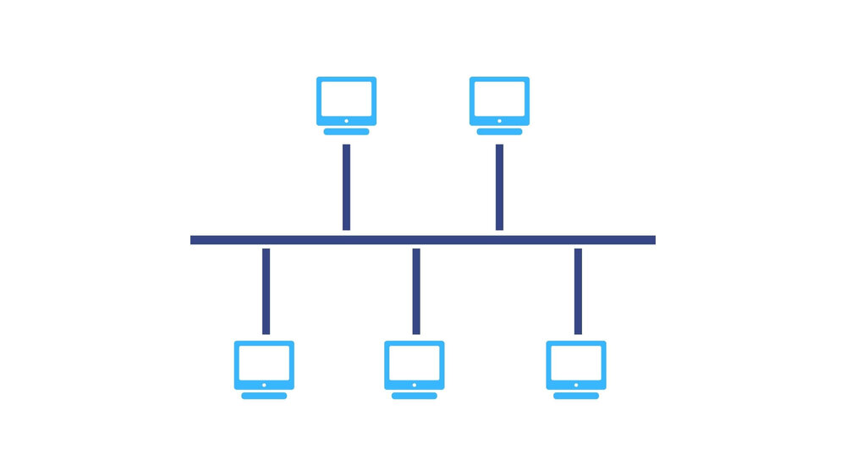

**4. STAR TOPOLOGY:**

A star topology is the one in which each peripheral node is connected to a central hub or switch. It is probably the most commonly used network topology for LAN because it is considered the easiest topology to design and implement. The central hub functions as the server for the peripheral nodes or clients. All the network traffic passes through the central hub and this is the only requirement for the topology to be classified as a star topology; the network doesn’t have to resemble a star in the physical arrangement.

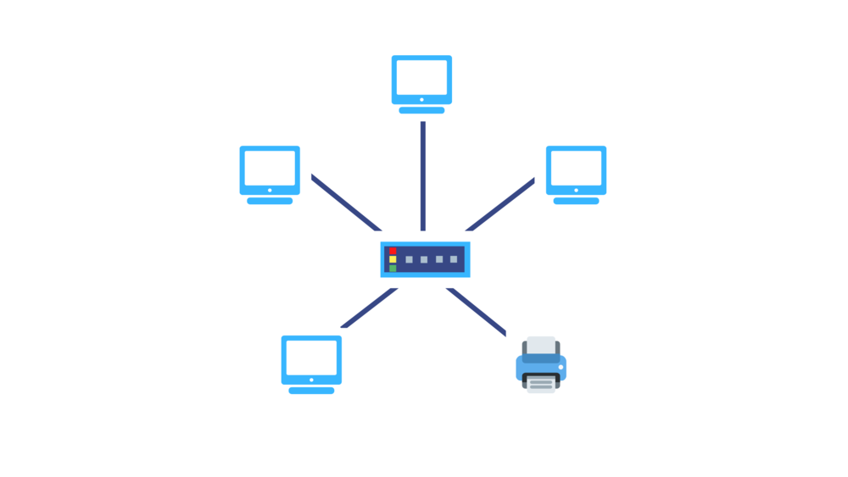

**5. RING TOPOLOGY:**

As we mentioned earlier, the ring topology is similar to a daisy chain topology but with the loop closed so that the nodes are arranged in a ring or circle. Each node has exactly two peers and the data travels in one direction passing through each intermediate node on the ring until it reaches the destination node. Data can be made to pass in both directions by adding a second connection between the network nodes, creating a dual ring topology.

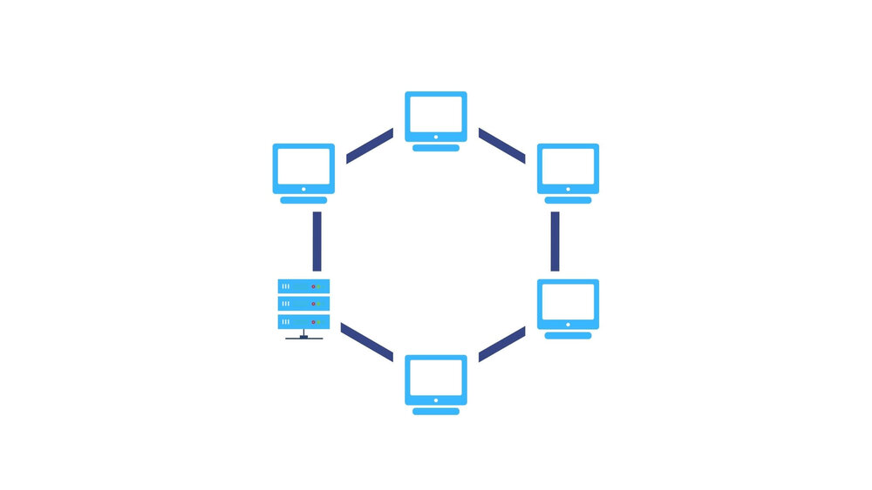

**6. MESH TOPOLOGY:**

A mesh topology is one in which the nodes connect directly and dynamically to many other nodes. It consists of an elaborate structure of point-to-point interconnections among the nodes. You can have a partial mesh topology, where some nodes have two or more connections, or a full mesh topology, where all nodes are fully connected to every other node.

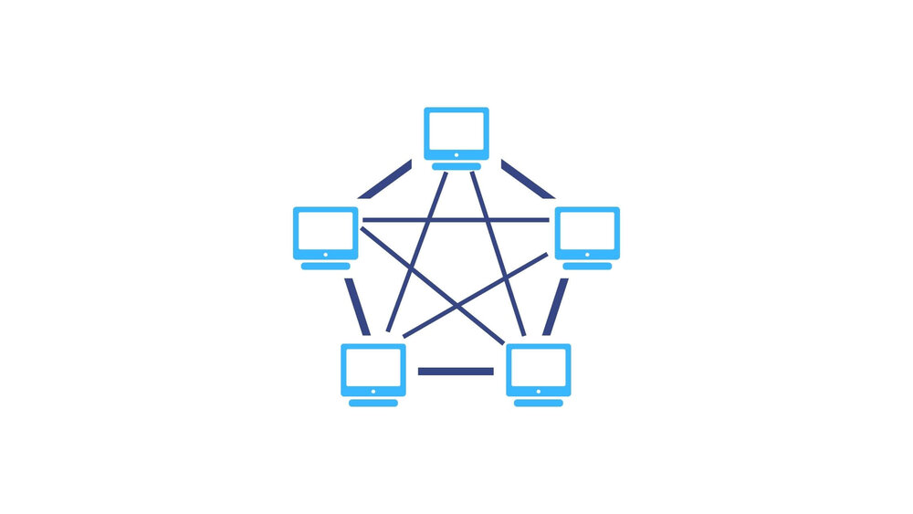

**7. HYBRID TOPOLOGY:**

A hybrid topology is one in which two or more distinct topologies are combined to build a network in such a way that it doesn’t exhibit any of the standard topologies. Hybrid topologies are commonly found in larger organizations where individual departments can have personalized network topologies based on their needs and network requirements.

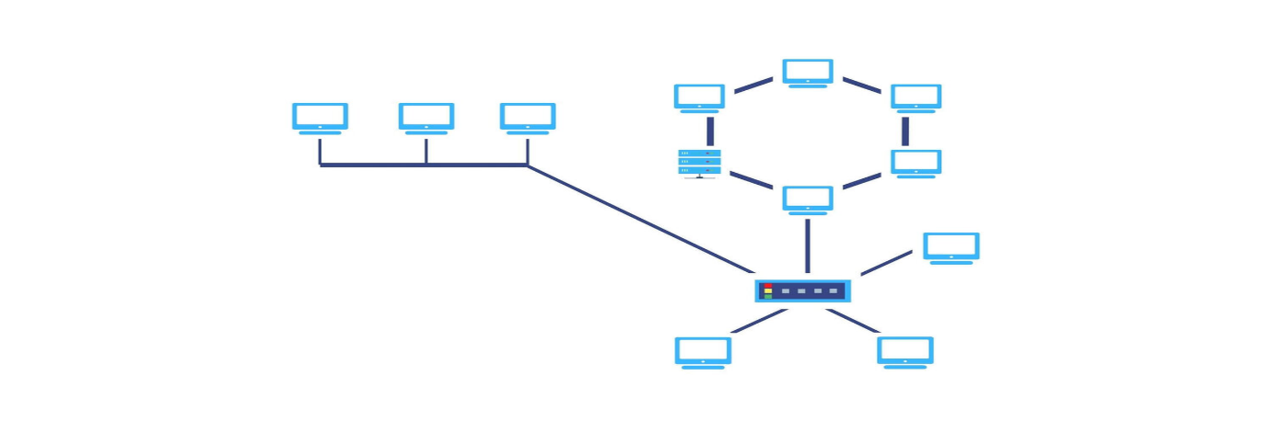

**8. TREE TOPOLOGY:**

A tree topology is a hybrid network resulting from the combination of a bus topology and a star topology. The bus resembles the trunk of the tree while the peripheral nodes resemble leaves, hence the name tree topology. The tree topology can be viewed as a hierarchical arrangement of star networks as it has a parent-child hierarchy to how the nodes are connected.

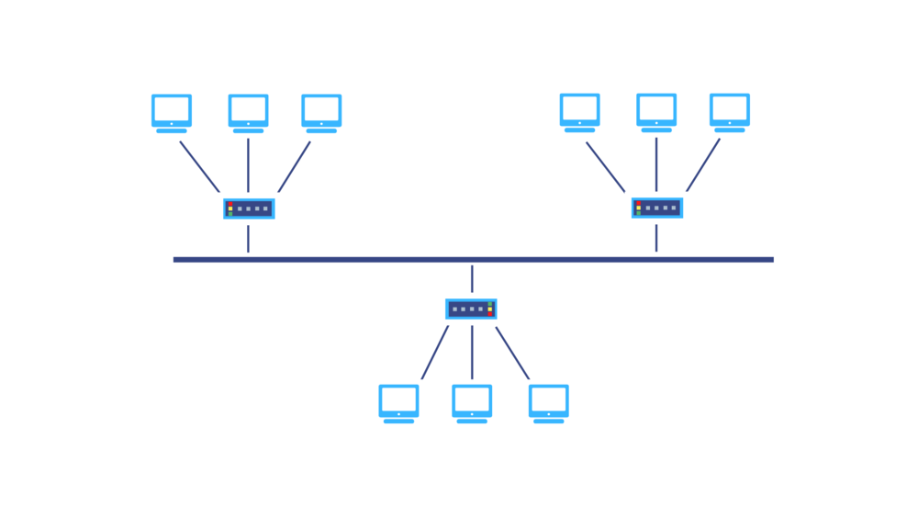

Accessing an environment like the RPS Lab typically involves several steps:

1. **Credentials**: You would need valid credentials provided by the organization or institution managing the RPS Lab. This might include a username and password, or other forms of authentication like SSH keys.
2. **Network Access**: Ensure that you have access to the network where the RPS Lab is hosted. This might involve being on-site physically or having VPN access if it's a remote setup.
3. **Remote Access Tools**: If it's a remote environment, you might use tools like SSH (Secure Shell) for command-line access, remote desktop tools, or web-based interfaces provided by the lab.
4. **Permissions and Roles**: Depending on your role (student, researcher, etc.), you might have different levels of access to resources within the RPS Lab. Make sure you have the appropriate permissions to perform the tasks you need to do.
5. **Security Protocols**: Follow any specific security protocols set by the administrators of the RPS Lab to ensure the integrity and safety of the environment and its data.